ASSIGNMENT-14.4

NAME: K.Dhana sri
ROLL.NO: 2303A52153 BATCH: 41

Task 1: Responsive Homepage Layout for a Startup Website
Scenario
You are designing a basic homepage for a startup company that needs to look good on desktops, tablets, and mobile devices.
Prompt:
Generate a simple responsive homepage using HTML and CSS.

Requirements:
- Header with navigation links (Home, About, Services, Contact)
- Main content section with a heading and paragraph
- Footer with basic information

Use CSS Flexbox and media queries to make the layout responsive for:
- Mobile
- Tablet
- Desktop

Keep the code clean, simple, and beginner friendly.

Provide two files: index.html and styles.css.
Code:
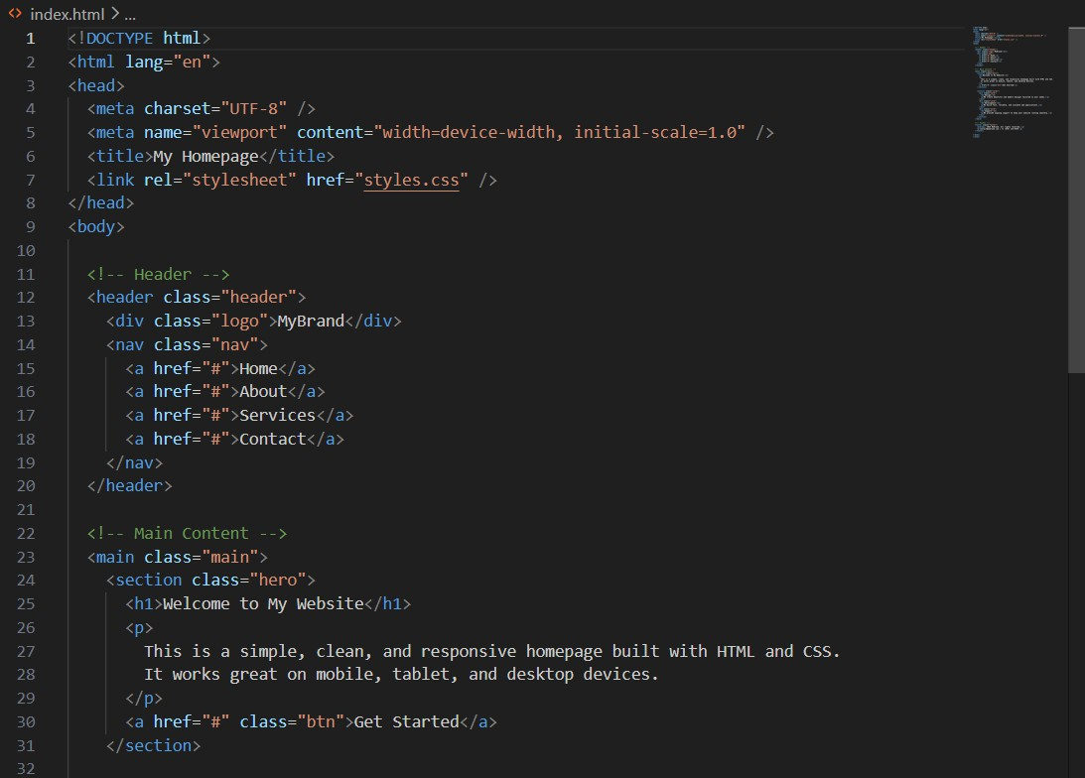

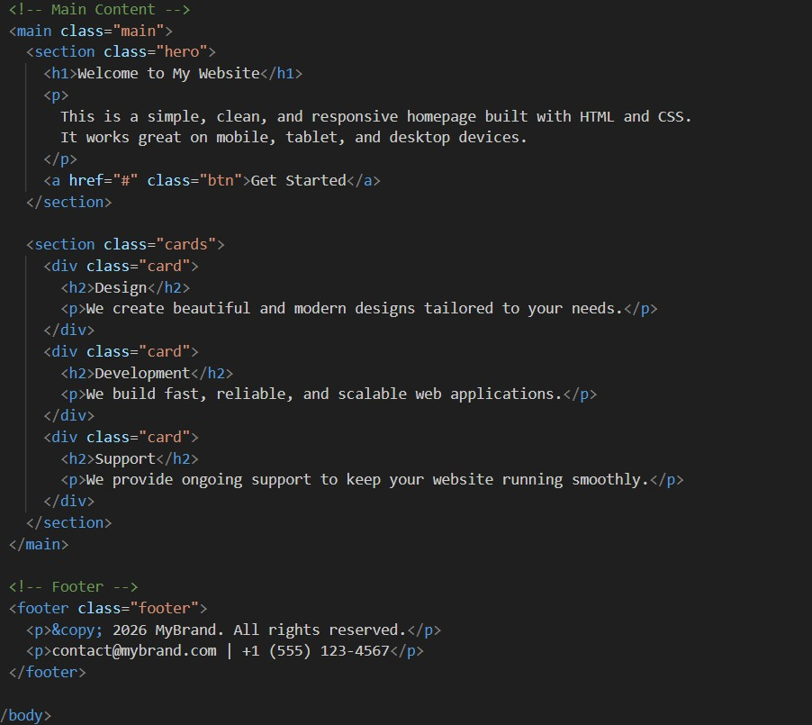
Output:
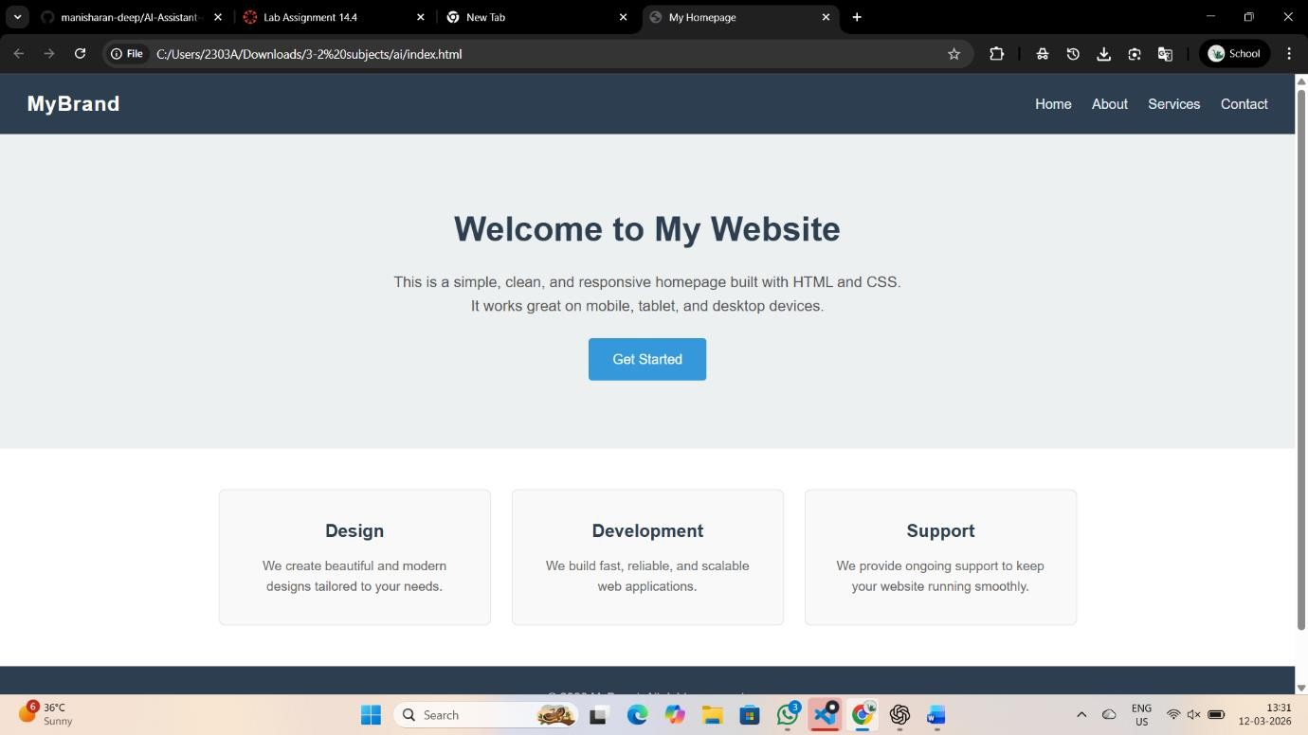

Justification:
A responsive homepage layout ensures that the website works properly on different devices such as mobile phones, tablets, and desktops. Using HTML provides a clear structure for the header, main content, and footer sections, making the page organized and easy to understand. CSS with media queries helps adjust the layout according to screen size, improving user experience and accessibility. This approach makes the website flexible, visually consistent, and suitable for modern web development standards.
Task 2: Interactive Call-to-Action Button
Scenario:
A marketing page requires a call-to-action button that responds when users interact with it.
Prompt:
Create a simple web page with an interactive Call-to-Action button using HTML, CSS, and JavaScript.

Requirements:
- Add a button labeled "Click Me".
- When the button is clicked, display a message or alert using JavaScript.
- Do not reload the page when the button is clicked.
- Add clear and meaningful comments in the JavaScript code explaining the logic.

Provide the complete code in one HTML file. Keep the code simple and beginner friendly. Code:

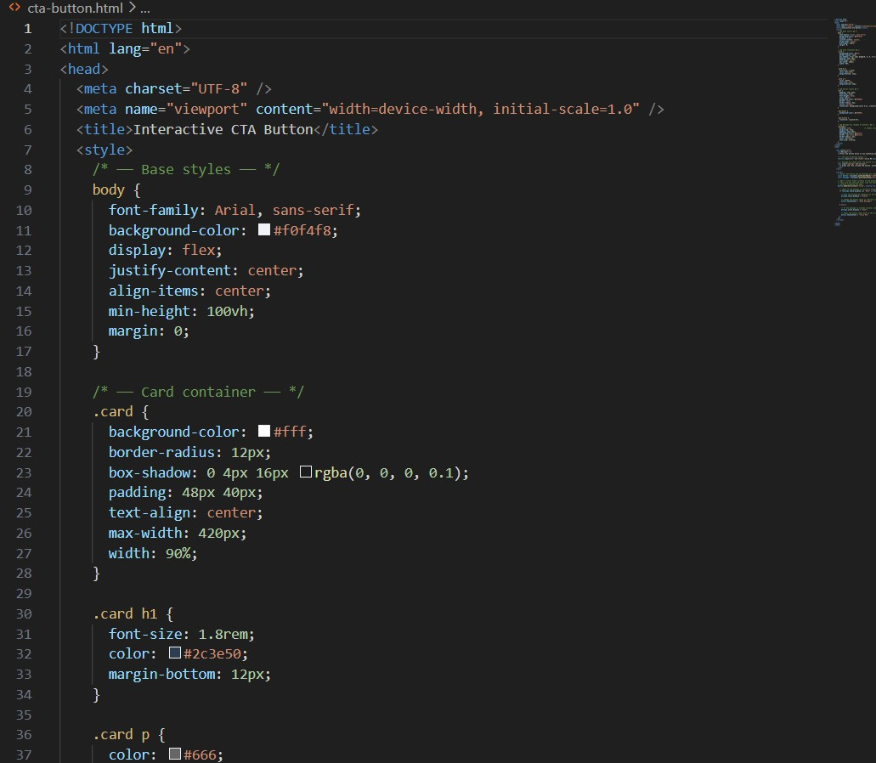

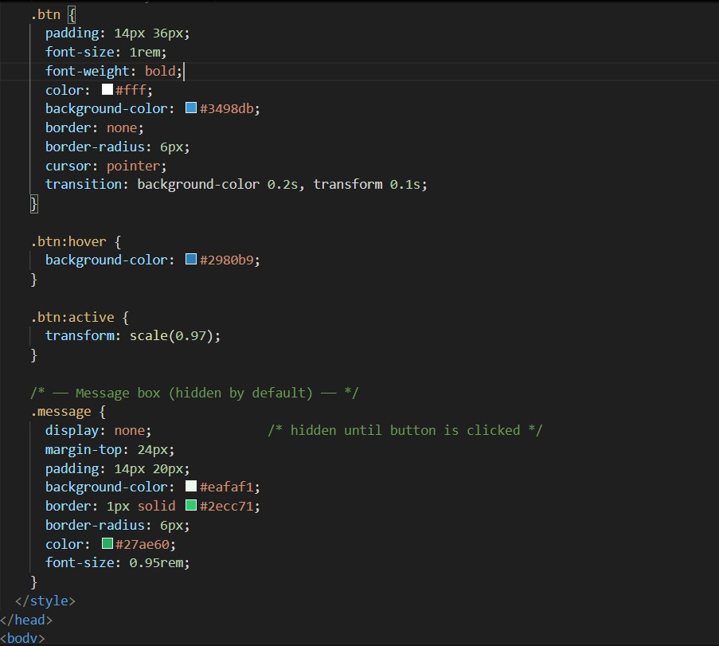

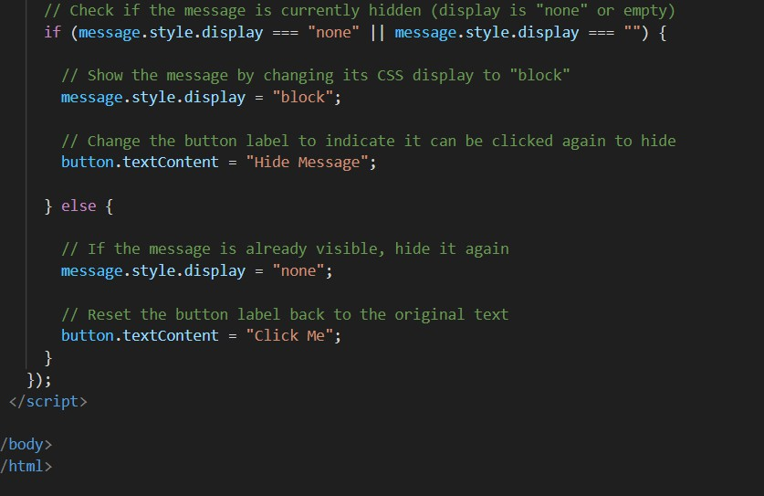
Output:
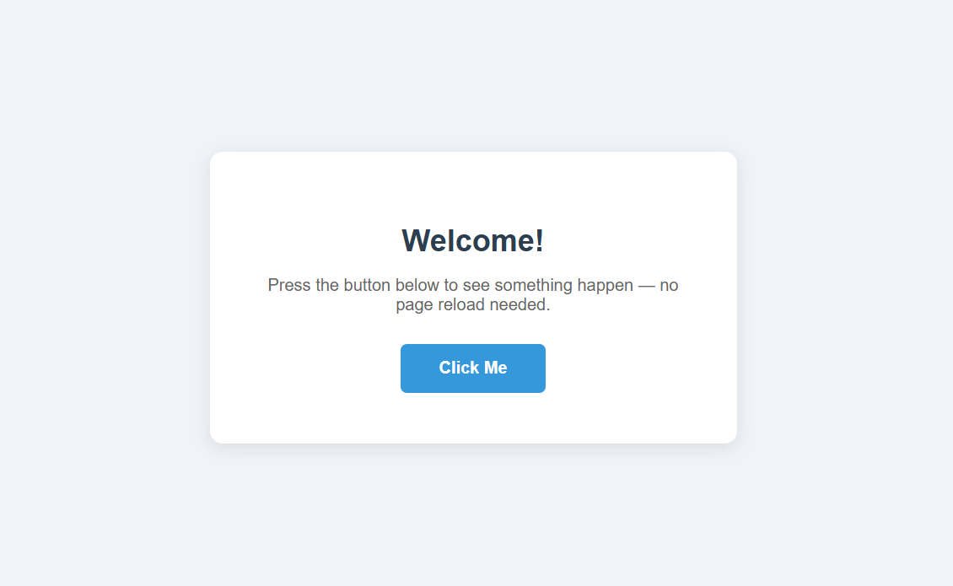

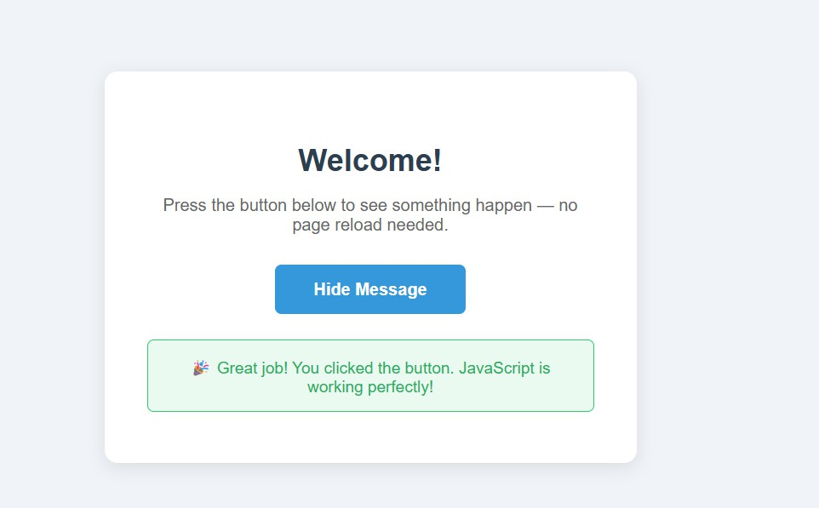
Justification:
An interactive Call-to-Action (CTA) button improves user engagement by allowing users to interact directly with the webpage. HTML is used to create the button element, while JavaScript handles the click event and displays a message or alert without reloading the page. Adding comments in the JavaScript code makes the logic easier to understand and maintain. This approach demonstrates basic event handling and enhances the overall user experience on the website.

Task 3: Contact Form with Client-Side Validation
Scenario
You are developing a contact form for a company website to collect user queries safely and correctly
prompt:
Create a simple Contact Form using HTML, CSS, and JavaScript.

Requirements:
- Form fields: Name, Email, and Message.
- Use JavaScript for client-side validation.
- Prevent form submission if fields are empty.

- Validate that the email format is correct.
- Show clear inline error messages for invalid inputs.
- Show a success message when the form is valid.
- Do not reload the page on validation.

Keep the code simple, clean, and beginner friendly. Provide the complete code in one HTML file.
Code:
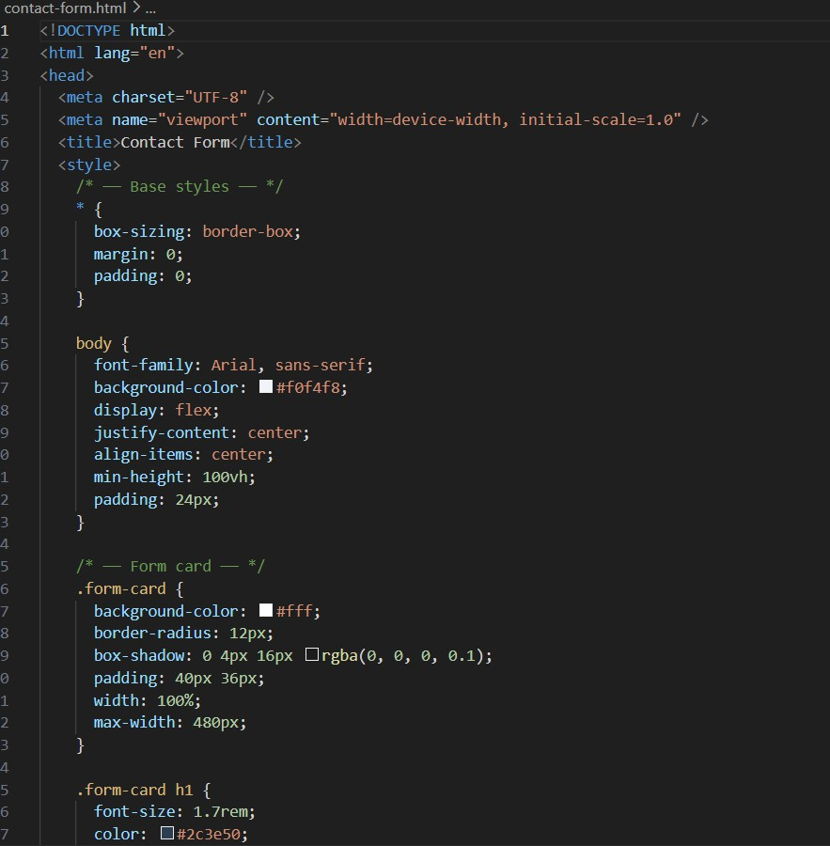

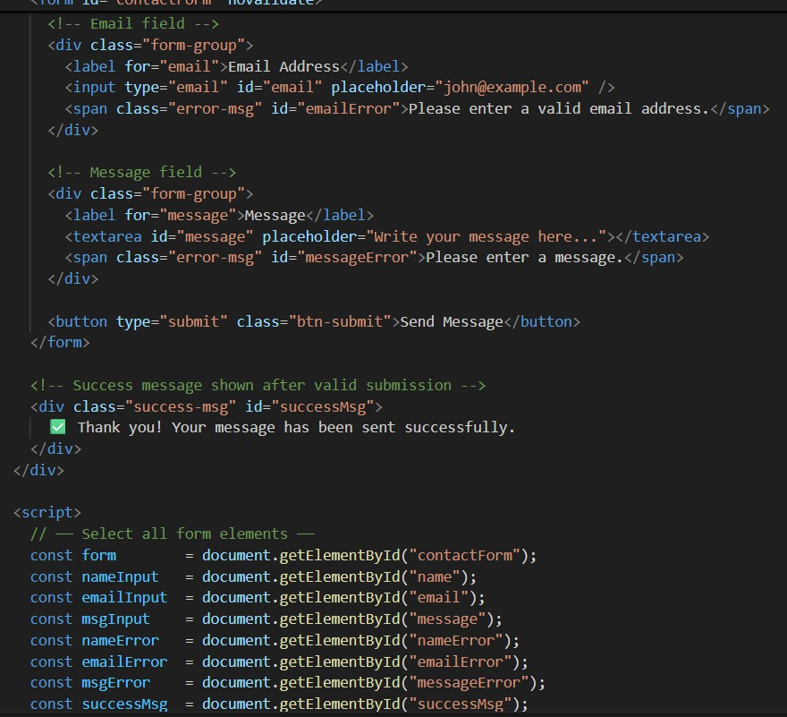

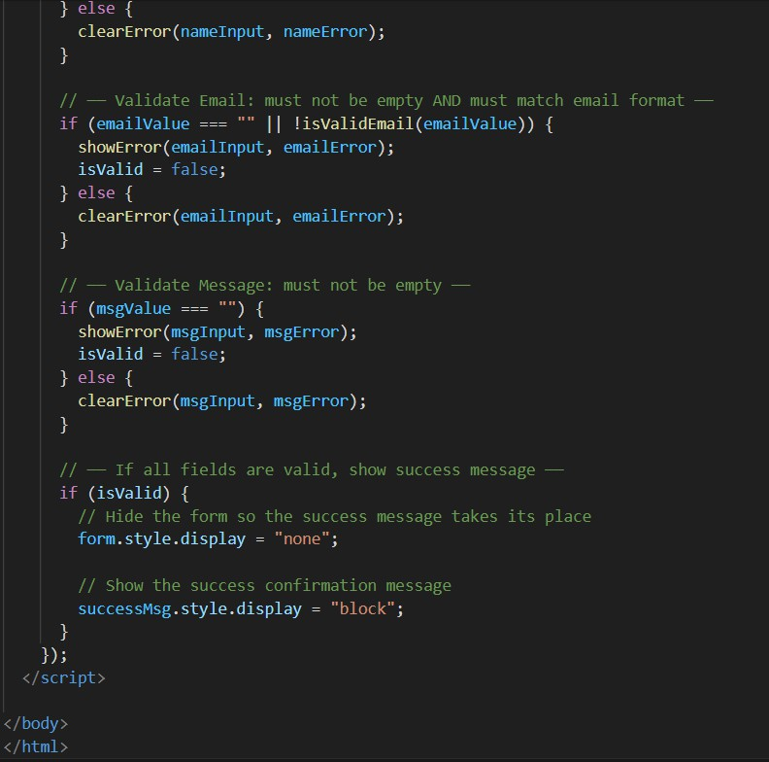

Output:

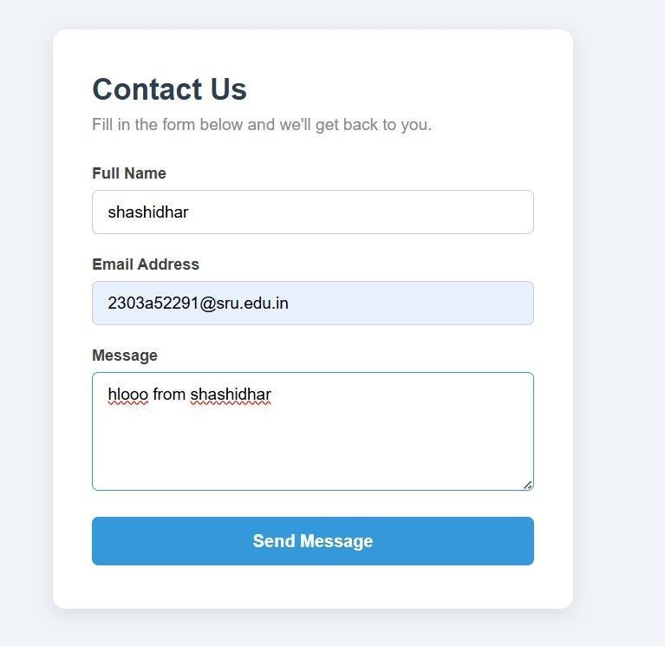
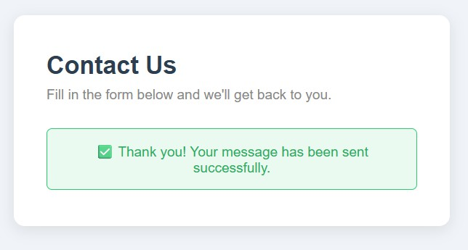

Task 4: Dynamic List Management for a Product Page
Scenario
A product listing page needs to add or remove items dynamically without refreshing the page.
Promt:
Create a simple web page using HTML, CSS, and JavaScript for dynamic list management.

Requirements:
- Display a list of items using an HTML unordered list.
- Add an input field and an "Add" button to insert a new item into the list.
- Add a "Remove" button to remove the last item from the list.
- Use JavaScript DOM manipulation to update the list dynamically.
- Ensure items are added and removed instantly without reloading the page.
- Add clear comments in the JavaScript code explaining the logic.

Provide the complete code in one HTML file. Keep it simple and beginner friendly.
Code:

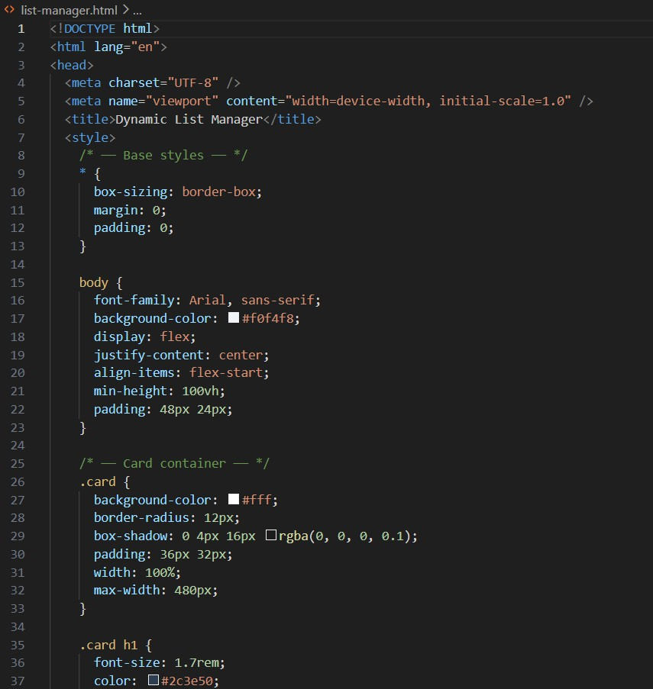

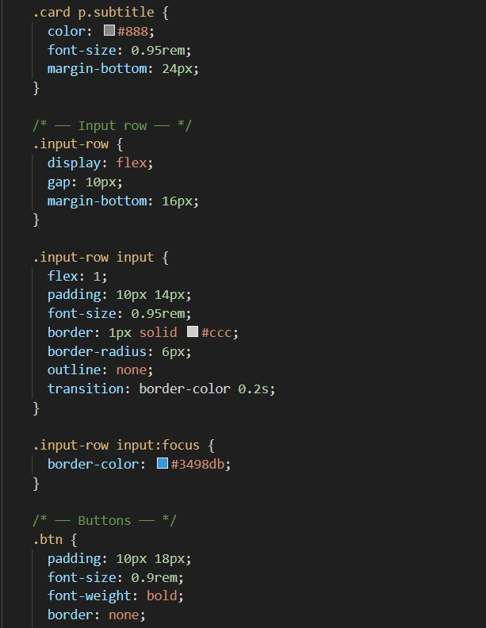

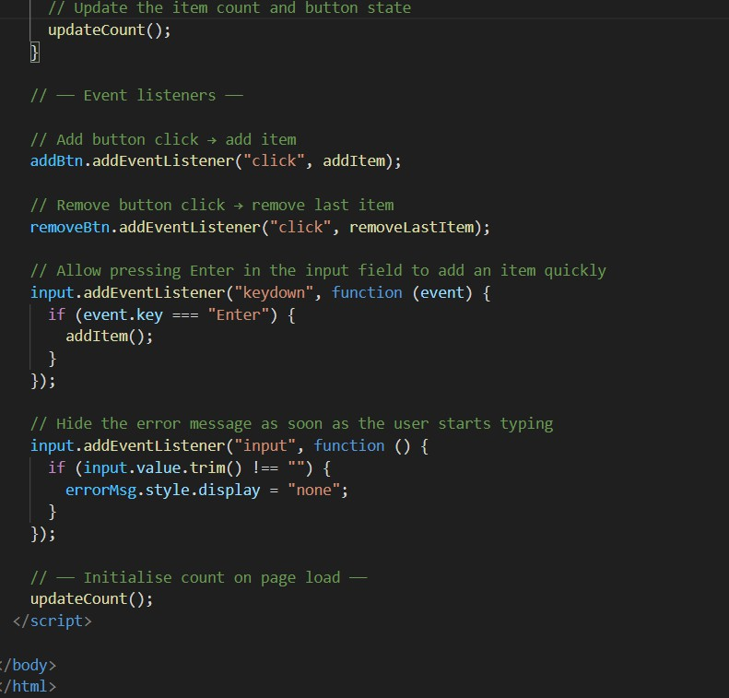
Output:

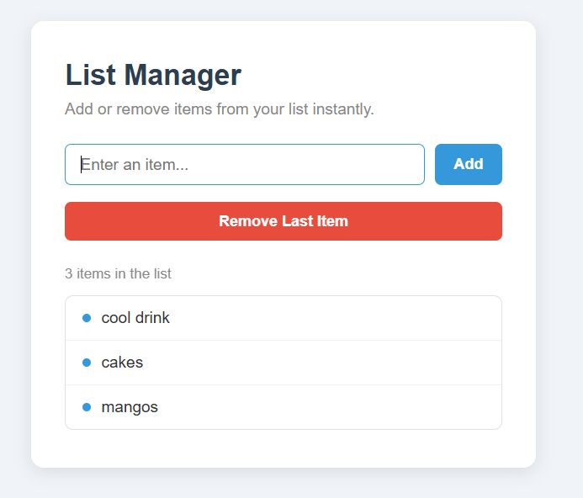
Justification:
Dynamic list management improves user interaction by allowing items to be added or removed from a webpage instantly without refreshing the page. HTML is used to create the list structure, while JavaScript manipulates the DOM to update the list dynamically when users click the Add or Remove buttons. This demonstrates basic DOM operations, event handling, and improves the responsiveness of the webpage.
Task 5: Modal Popup for User Notifications
Scenario:
You are building a user notification popup for announcements or alerts on a website.
Promt:
Create a simple Modal Popup notification using HTML, CSS, and JavaScript.

Requirements:

- Add a button labeled "Open Modal".
- When the button is clicked, display a modal popup in the center of the page.
- The modal should have a semi-transparent background overlay.
- Include a close button inside the modal.
- Allow the modal to close when the close button or the overlay is clicked.
- Use JavaScript to handle opening and closing of the modal.
- Keep the code simple, clean, and well commented.

Provide the complete code in one HTML file.
Code:

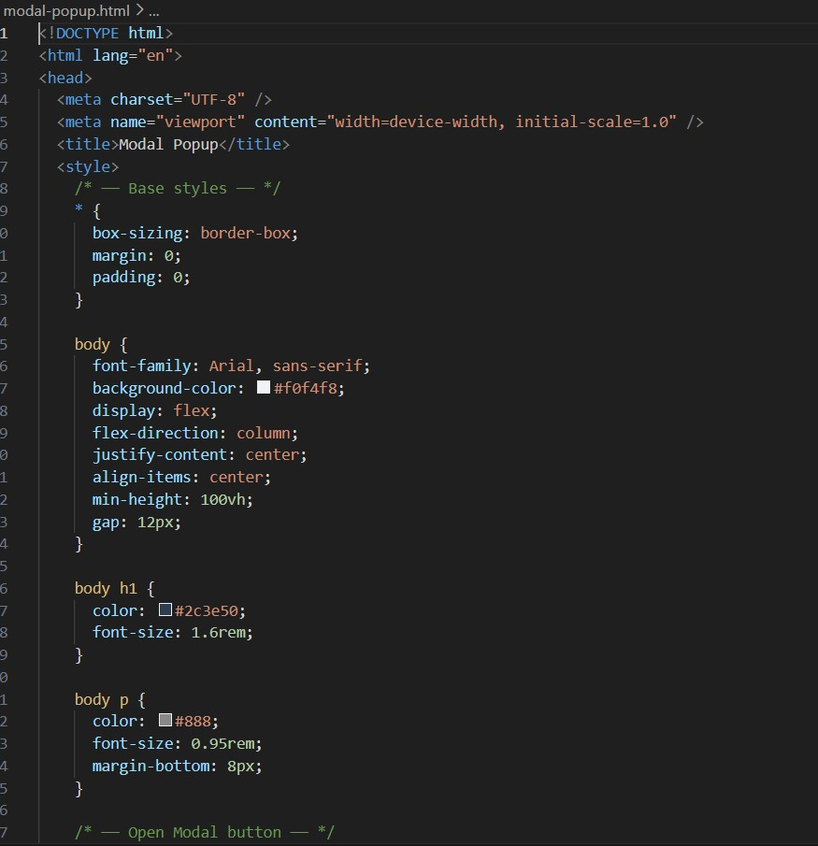

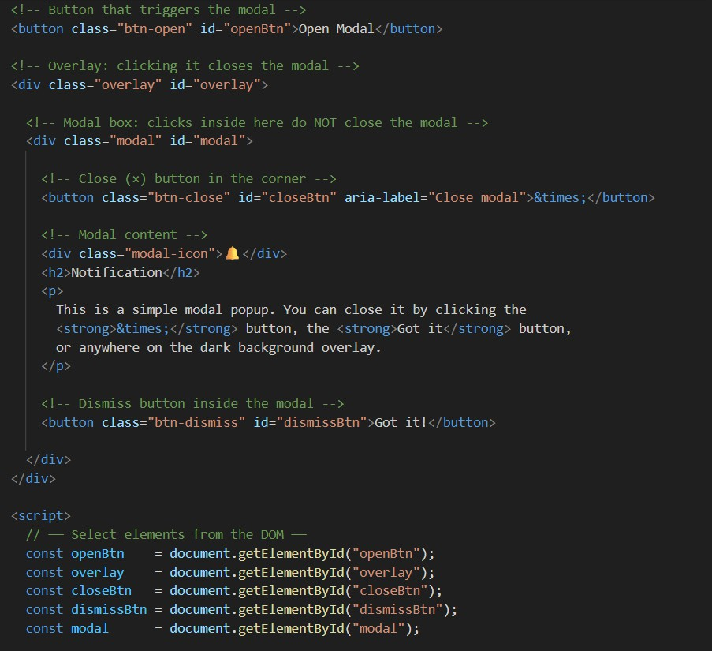

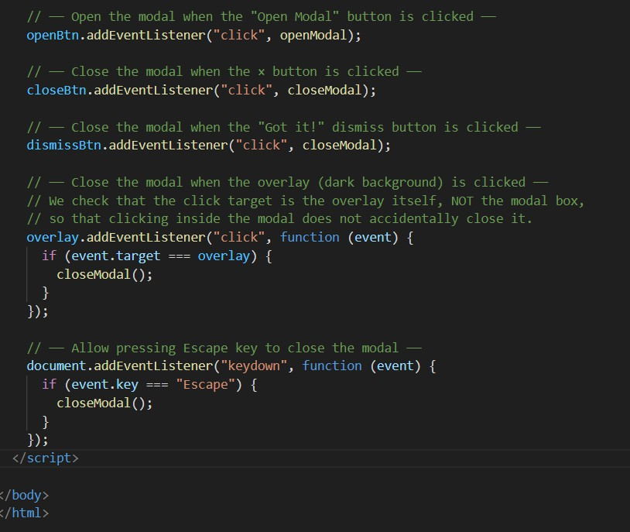
Output:
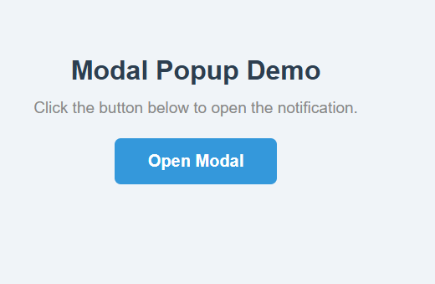

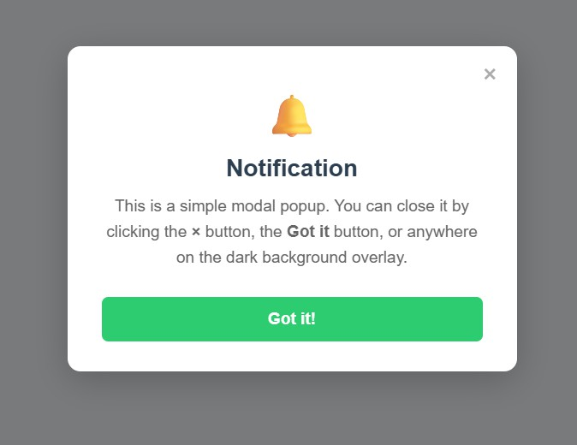

Justification:
A modal popup is useful for displaying important notifications, announcements, or alerts without navigating away from the current page. HTML creates the modal structure, CSS provides styling and a semi-transparent overlay to focus user attention, and JavaScript controls opening and closing actions. Allowing multiple ways to close the modal improves usability and provides a better user experience.

